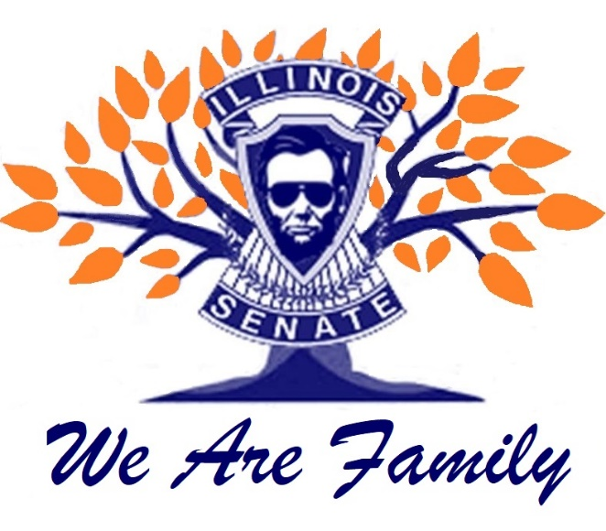

ELECTIONS 2021 -22 year

The following Senators have announced / been nominated (shanghaied) for offices in the ensuing Senate year!

President - Lynn McGill
Admin VP - (no candidate yet)
Management VP - (no candidate yet)
Treasurer - Roxy Hollenstine
Secretary - Donna Baker
Fox Valley RD - JoAnn Smith
Gateway RD - Cindy Ogden
Mississippi Valley - Susie C.C.
North RD - Bruce Widenhoeffer
Northeast RD - Yvonne A.A.
Northwest RD - Terry Barker
Prairieland RD - Russ Cooper
South RD - Melodie Ainslie
South Central RD - Rod Hollenstine
SERVE RD - Monty Schroeder (Life nomination)

CONGRATULATIONS ONE AND ALL
couple of vacancies – step up!!!!

